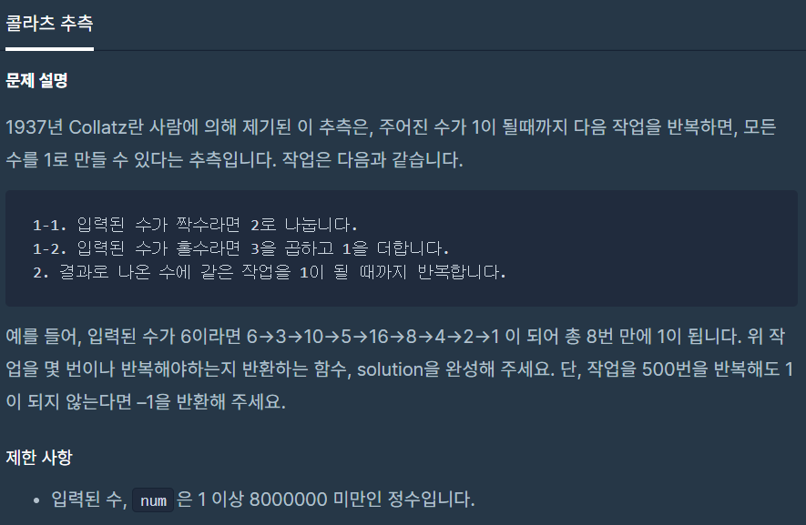

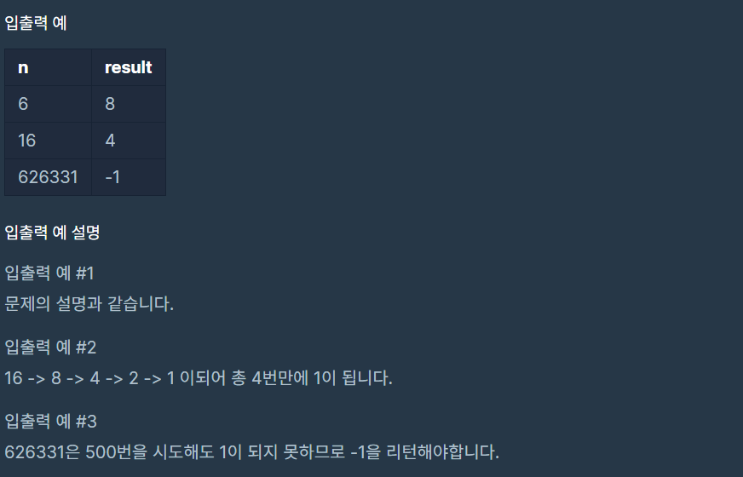

**문제 링크주소 :** <https://programmers.co.kr/learn/courses/30/lessons/12943>

**풀이**

var count = 0;

function solution(*num*) {

    var answer = 0;

    call();

    function call(){

        if(*num* === 1){

            return;

        }

        else if(*num*%2 === 0){

*num*=*num*/2;

            count++;

            call();

        }

        else if(*num*%2 === 1){

*num*=*num*\*3+1;

            count++;

            call();

        }

    }

    if(count>500){

        return -1;

    }else{

        return count;

    }

}